**Circuit and System-I**

**LAB # 01**



**Spring 2019**

Submitted by: **Shah Raza**

Registration No.: **18PWCSE1658**

Class Section: **B**

“On my honor, as student of University of Engineering and Technology, I have neither given nor received unauthorized assistance on this academic work.”

Student Signature: ______________

Submitted to:

**Engr. Muneeba Ashfaq**

18 Feb 2019

Department of Computer Systems Engineering

University of Engineering and Technology, Peshawar

**Title:**

**“INTRODUCTION TO BASIC EKECTRICAL EQUIPMENT’S”**

**Objectives:**

1) To know about different basic electrical equipment and components.

2) Use of these basic equipment.

3)How to connect the voltmeter and ammeter in the circuit.

4)Use of DMM.

**Apparatus:**

1. Voltmeter.
2. Ammeter.
3. Ohm meter.
4. Power supply.
5. Bread board.

**THEORY:**

**Resistance:**

**“**Electrical resistance is a measure of the degree to which an object opposes the passage of an electric current. The SI unit of electrical resistance is the ohm.”

**Mathematically:**

**R = V/I**

**Current:**

**“**Current is a flow of electrical charge carriers, usually electrons or electron-deficient atoms. The common symbol for current is the uppercase letter I. The standard unit is the ampere’, symbolized by A.**”**

**Mathematically:**

**I = V/R**

**Voltage:**

**“**Voltage, also called *electromotive force*, is a quantitative expression of the potential difference in charge between two points in an electrical field.”

**Mathematically:**

**V = IR**

**Apparatus explanation:**

**DIGITAL MULTIMETER (DMM):**

**“**A digital multimeter or DMM is one of the most widely used pieces of test equipment today. DMMs are available very cheaply and these digital multimeters can provide very high degrees of accuracy when measuring the parameters within an electronics or electrical circuit. As a result, DMMs are one of the most indispensable pieces of test equipment available today.”

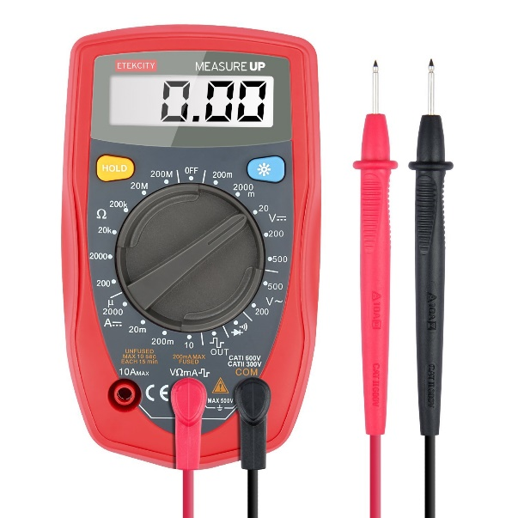

**Parts of a Multimeter:**

A multimeter mainly has two parts:

* Selection Knob
* Probes

**Selection Knob:**

The selection knob enables the user to set the multimeter to read different things such as Current, voltage and resistance. The user can also set the multimeter in different ranges.

**Probes:**

A multimeter has two probes. These probes are used to connect the multimeter in a circuit.

**VOLTMETER:**

**Definition:**

A voltmeter is a device used to measure the voltage potential between two points in an electrical circuit.

**Procedure:**

To find the voltage in circuit we use the voltmeter. We connect the voltmeter in parallel in the circuit. We first bring the voltmeter in range. And clear that you are measuring the DC voltage OR AC Voltage. Now connect the Probes of voltmeter to the selected place in the circuit. If we connect the probes oppositely than Voltmeter show us negative voltage on the screen.

**AMMETER:**

An **ammeter** (from **Am**pere **Meter**) is a measuring instrument used to measure the current in a circuit.

**Procedure:**

To find the current in circuit we connect the ammeter in the circuit in series. First we bring the ammeter in the range. Than we connect the probes of Ammeter to selected place in the circuit and read the current on the screen of Ammeter.

**OHMMETER:**

An **ohmmeter** is an electrical instrument that measures electrical resistance, the opposition to an electric current.

**Procedure:**

To find the resistance of a wire or a material we connect the ohmmeter probes with the material in parallel. We bring the ohmmeter in the range. And note the value on the screen.

**POWER SUPPLY:**

A **power supply** is an electrical device that supplies electric power to an electrical load. The primary function of a power supply is to convert electric current from a source to the correct voltage, current, and frequency to power the load. As a result, power supplies are sometimes referred to as electric power converters.

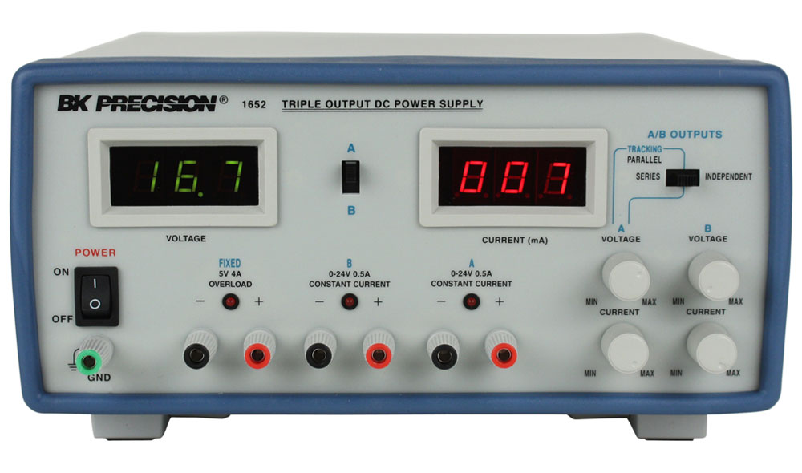

**TYPES OF POWER SUPPLY:**

* **AC POWER SUPPLY**
* **DC POWER SUPPLY**
* **HIGH VOLTAGE POWER SUPPLY**
* **BIPOLAR POWER SUPPLY**

SPECIFICATION OF POWER SUPPLY:

The suitability of a particular power supply for an application is determined by various attributes of the power supply, which are typically listed in the power supply's *specification*. Commonly specified attributes for a power supply include:

* Input voltage type (AC or DC) and range
* Efficiency of power conversion
* The amount of voltage and current  it can supply to its load
* How stable its output voltage or current is under varying line and load conditions
* How long it can supply energy without refueling or recharging (applies to power supplies that employ portable energy sources)

**BREAD BOARD:**

A **breadboard** is a construction base for prototyping of electronics.

**Connections inside Bread Board:**

Inside in the bread board the middle part are connected vertically. The upper two lines are connected parallel.

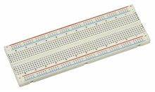

.

**ANALYSIS:**

1) We take different types of resistors.

2) Put these resistors in the bread board.

3) we use ohmmeter and find the resistance of the resistor.

4) Now we connect the different types of voltages to resistor and calculate the voltage by the help of voltmeter.

5) Now using the following formula and find the current in the circuit.

**I = V/R**

6) And to find the percentage error we use the following formula:

% Error = Actual voltage –Measured voltage \***100**

Actual voltage

OBSERVATION:

|  |  |  |  |  |  |
| --- | --- | --- | --- | --- | --- |
| S.No. | Actual voltage | Measured voltage | Resistance | I=V/R | % ERROR |
| 1 | 5 VOLT | 5.2 VOLT | 57k Ω | 9.1*10-5 A | 4 % |
| 2 | 15 VOLT | 15.15 VOLT | 22.2k Ω | 6.8*10-4 A | 1 % |
| 3 | 10 VOLT | 9.96 VOLT | 101 Ω | 9.8*10-2 A | 0.4 % |
| 4 | 15 VOLT | 15.10 VOLT | 9 Ω | 1.67 A | 0.67 % |
| 5 | 20 VOLT | 20.3 VOLT | 9 Ω | 2.25 A | 1.5 % |
| 6 | 30 VOLT | 30.2 VOLT | 9 Ω | 3.35 A | 0.67 % |

**CONCLUSION:**

In above experiment we find resistance with the help of power supply. Also we know about galvanometer, voltmeter, digital multimeter, and ohm meter.